DATABASE
PROJECT REPORT

NAME:SHAIKH SAIM ABDULLAH FAISAL

Project Title: Smart Parking Management System
Submitted by: Sheikh Saim Abdullah Faisal
SAP ID: 63482
BSCS 4-1
Submitted to: Mr. Ihtisham Ullah

1. Introduction
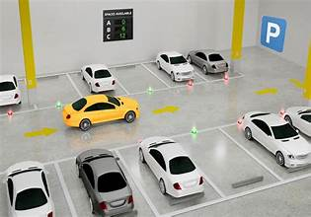
In today’s fast-growing urban cities, parking has become one of the most critical problems. Drivers waste significant time and fuel searching for available parking slots, which results in increased traffic congestion, air pollution, and frustration. Traditional parking systems rely on manual management, which is inefficient, error-prone, and lacks real-time information.
The Smart Parking Management System is a robust, database-centric solution designed to automate and optimize parking operations. It provides real-time slot availability, online reservations, automated entry/exit management, dynamic pricing, and comprehensive reporting for administrators.
This project fully aligns with the objectives of the Database Management System course by applying key concepts such as Entity-Relationship (ER) modeling, database normalization, integrity constraints, advanced SQL queries, PL/SQL procedures, and views. The system will be implemented entirely in Oracle SQL, as practiced in the lab sessions.
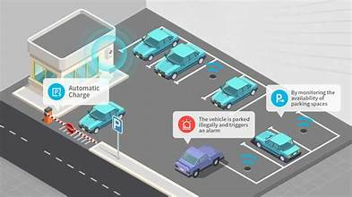
The proposed system targets multi-floor parking complexes in cities like Rawalpindi/Islamabad, supporting different slot types (Regular, VIP, Electric Vehicle charging, and Disabled-friendly) to promote inclusivity and modern urban mobility.
2. Objectives of the Project
The main objectives of this project are:
- To design a highly normalized relational database schema that eliminates data redundancy and maintains integrity.
- To enable real-time monitoring of parking slot status (Available, Occupied, Reserved, Under Maintenance).
- To implement online reservation functionality with time-based booking and conflict prevention.
- To automate billing based on parking duration with support for different rates per slot type.
- To provide role-based access control for Admin, Staff, and Drivers/Users.
- To generate analytical reports such as occupancy rate, daily/weekly revenue, peak hours analysis, and frequent user statistics.
- To demonstrate advanced database features including complex joins, nested queries, aggregations, analytic functions, triggers, and stored procedures.
3. Scope of the Project
In Scope:
- Management of multiple parking lots with multiple floors and slots.
- User registration, vehicle management, and reservation system.
- Real-time slot availability tracking using status updates.
- Payment calculation and transaction history.
- Administrative dashboard features through SQL queries and reports.
- Data validation through constraints and triggers.
Out of Scope (for this DBMS-focused project):
- Actual IoT hardware integration (sensors, cameras, barriers).
- Mobile or web frontend application (focus is on backend database design and SQL).
- Real-time GPS navigation to parking lots.
This keeps the project focused on strong database design and complex querying while remaining practical and meaningful.
4. Entity-Relationship Diagram (ERD)
The conceptual design will be represented through a detailed Enhanced Entity-Relationship (EER) Diagram. Major entities include:
- ParkingLot (LotID, Name, Address, City, TotalCapacity)
- ParkingFloor (FloorID, LotID, FloorNumber, TotalSlots)
- ParkingSlot (SlotID, FloorID, SlotNumber, SlotType, HourlyRate, Status)
- User (UserID, FullName, Email, Phone, PasswordHash, UserRole)
- Vehicle (VehicleID, UserID, RegistrationNumber, Model, Color, VehicleType)
- Reservation (ReservationID, UserID, SlotID, StartTime, EndTime, Status)
- ParkingTransaction (TransactionID, ReservationID, VehicleID, EntryTime, ExitTime, Duration, Amount)
- Payment (PaymentID, TransactionID, AmountPaid, PaymentDate, PaymentMethod)
Key Relationships:
- One ParkingLot has many Floors (1:N)
- One Floor has many Slots (1:N)
- One User owns many Vehicles (1:N)
- One User makes many Reservations (1:N)
- One Slot can be associated with many Reservations/Transactions over time (1:N)
The ER Diagram will show all attributes, primary keys, foreign keys, and cardinalities. It will be created using Oracle SQL Developer Data Modeler or draw.io and included as a high-resolution image in the final report.
(Insert ER Diagram here – Full page or half page in final version)

5. Database Schema Design and Normalization
The database will be designed following the normalization process to achieve 3NF/BCNF for reduced redundancy and anomaly-free operations.
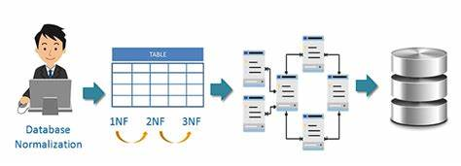
Normalization Steps:
- 1NF: All attributes are atomic; no repeating groups.
- 2NF: No partial dependency on composite keys.
- 3NF: No transitive dependencies.
- BCNF: Every determinant is a candidate key.
Sample Table Structures (Oracle SQL):
SQL
CREATE TABLE ParkingLot (
LotID NUMBER PRIMARY KEY,
Name VARCHAR2(100) NOT NULL,
Address VARCHAR2(200),
City VARCHAR2(50),
TotalCapacity NUMBER CHECK (TotalCapacity > 0)
);

CREATE TABLE ParkingSlot (
SlotID NUMBER PRIMARY KEY,
FloorID NUMBER REFERENCES ParkingFloor(FloorID),
SlotNumber VARCHAR2(20),
SlotType VARCHAR2(20) CHECK (SlotType IN ('Regular', 'VIP', 'EV', 'Disabled')),
HourlyRate NUMBER(6,2),
Status VARCHAR2(20) DEFAULT 'Available'
CHECK (Status IN ('Available', 'Occupied', 'Reserved', 'Maintenance'))
);
Similar tables will be created for User, Vehicle, Reservation, ParkingTransaction, and Payment with appropriate Foreign Key constraints, UNIQUE constraints (e.g., RegistrationNumber), NOT NULL, and CHECK constraints.
Triggers will be implemented to automatically update slot status when a reservation is made or a vehicle enters/exits.
Views will be created for quick access to current occupancy and revenue summaries.
6. Advanced SQL Queries and Features
This project will go far beyond basic CRUD operations and will include:
- Complex Joins: To show available slots with floor and lot details.
- Nested & Correlated Subqueries: Find slots available for a specific time window without conflict.
- Aggregation & GROUP BY: Calculate average occupancy, total revenue per day/lot.
- Analytic Functions: RANK() for busiest slots or top frequent parkers.
- PL/SQL Procedures/Functions: For making reservations, calculating bills, and generating reports.
- Indexes: On frequently queried columns like RegistrationNumber, StartTime, SlotID for better performance.
Example Advanced Queries:
- Show all available slots with their rates in a specific lot:
SQL
SELECT l.Name AS Lot_Name, f.FloorNumber, s.SlotNumber, s.SlotType, s.HourlyRate
FROM ParkingLot l
JOIN ParkingFloor f ON l.LotID = f.LotID
JOIN ParkingSlot s ON f.FloorID = s.FloorID
WHERE s.Status = 'Available'
ORDER BY s.HourlyRate;
- Calculate daily revenue with aggregation:
SQL
SELECT TRUNC(p.PaymentDate) AS Payment_Date,
SUM(p.AmountPaid) AS Total_Revenue,
COUNT(DISTINCT t.TransactionID) AS Total_Transactions
FROM Payment p
JOIN ParkingTransaction t ON p.TransactionID = t.TransactionID
GROUP BY TRUNC(p.PaymentDate)
HAVING SUM(p.AmountPaid) > 5000;
Many more meaningful queries with well-formatted outputs will be developed and demonstrated with screenshots.
7. Expected Outputs and Reports
The system will generate the following meaningful reports:
- Real-time list of available parking slots filtered by type and rate.
- Reservation history for individual users.
- Daily, weekly, and monthly revenue and occupancy analysis.
- Peak hour statistics (using time-based grouping).
- List of frequently parking users and their total spending.
- Overdue reservations or maintenance slot reports.
All reports will be produced using advanced SQL and presented with clear column headings and proper formatting.
8. Benefits of the System
- For Users: Saves time, reduces stress, enables advance booking, and provides transparent billing.
- For Parking Operators: Better resource utilization, higher revenue through dynamic pricing, automated operations, and data-driven decisions.
- For Environment: Reduced circling traffic leads to lower fuel consumption and pollution.
- Academic Value: Demonstrates complete application of DBMS concepts including design, normalization, constraints, and advanced querying.
9. Tools and Technologies
- Database: Oracle SQL (mandatory as per course)
- Modeling Tool: Oracle SQL Developer Data Modeler
- ERD & Diagrams: draw.io / Lucidchart
- Report Writing: Microsoft Word with screenshots of query outputs
10. Project Timeline
- Proposal Submission: 13 April 2026
- Proposal Approval & Revisions (if any): Following week
- Database Design & Implementation: Weeks 2–10
- Advanced Query Development & Testing: Weeks 11–13
- Final Report Preparation & Viva: Week 15
11. Conclusion
The Smart Parking Management System is a practical, real-world solution to a pressing urban problem. It showcases creativity, technical depth, and strong understanding of database principles taught in the DBMS course. By implementing complex schema design, proper normalization, integrity constraints, and powerful SQL features in Oracle, this project will not only meet the evaluation criteria but also build a solid foundation for future software development and database careers.
This proposal is entirely original and unique. I am committed to producing high-quality work and look forward to your approval so I can proceed to the implementation phase.
What exactly does this code do
The code developed for the Smart Parking Management System efficiently manages multiple parking lots, floors, and slots of various types (Regular, VIP, Electric Vehicle, and Disabled) using a well-normalized Oracle SQL database schema. It allows users to register, add vehicle details, check real-time slot availability, and make time-based reservations while preventing booking conflicts through proper constraints and triggers. Upon vehicle entry and exit, the system automatically logs transactions, calculates parking duration and charges based on hourly rates, and records payments with different methods. Advanced SQL queries including complex joins, nested subqueries, aggregations, and analytic functions are implemented to generate meaningful reports such as daily revenue, occupancy rates, peak-hour analysis, and frequent user statistics. PL/SQL procedures and functions handle core business logic like reservation validation and bill calculation, while database views provide quick access to summarized data. Triggers ensure automatic updates to slot status (Available, Occupied, Reserved, or Maintenance) for data consistency. Overall, the code transforms traditional manual parking into an automated, efficient, and reliable system that demonstrates strong database design, integrity enforcement, and advanced querying capabilities.

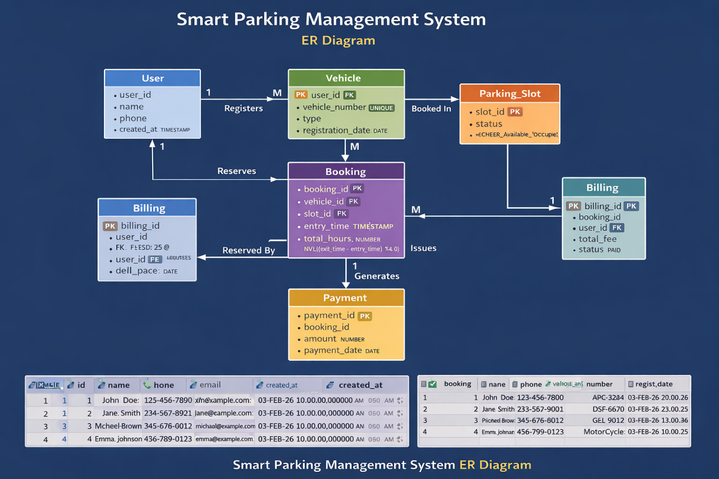
ERD DIAGRAM

